Social Entrepreneurship Summit of EUNIC
Athens, 2-3 December 2013
Venues:
2 December, Instituto Cervantes de Atenas, 23 Mitropoleos Street, 105 57 Athens
3 December, British Council, 17 Kolonaki Square, 106 73 Athens

As part of the EUNIC (European Union National Institutes for Culture) programme “Think Social. Act Business”, policy influencers, social enterprises and experts from across Europe will come together in Athens for a one-day policy dialogue and parallel workshops to share and learn from experiences in the Social Enterprise sector in the region.

The project builds on the special focus of the European Commission on Social Economy Development, and responds to an evidenced need for 1) increased opportunities for sharing expertise, 2) a need to develop the support structures that allow social enterprises to flourish and 3) the opportunity for transnational capacity building of the social entrepreneurship ecosystem.

The conference is organised by the Austrian Embassy in Athens, the British Council, Goethe Institute, Italian Cultural Institute, Instituto Cervantes, the Polish Embassy in Athens and 180o and supported by Konrad-Adenauer-Stiftung, the Anna Lindh Foundation, Municipality of Athens and Athens Development and Destination Management Agency and John S. Latsis Public Benefit Foundation.

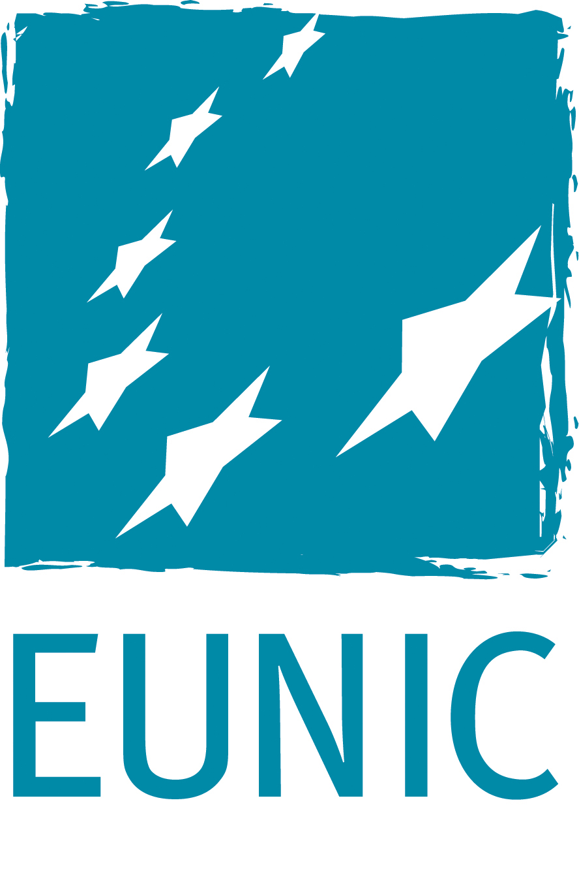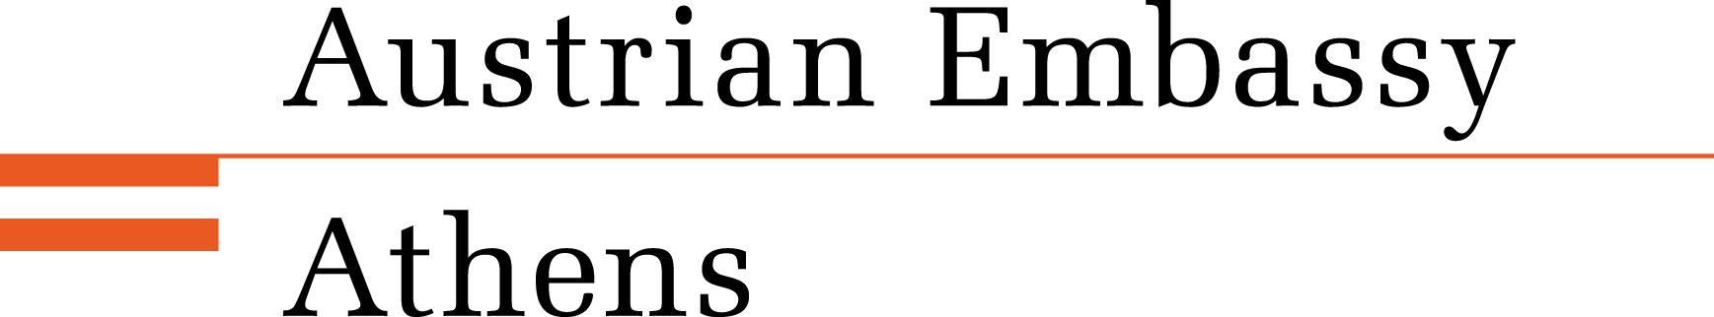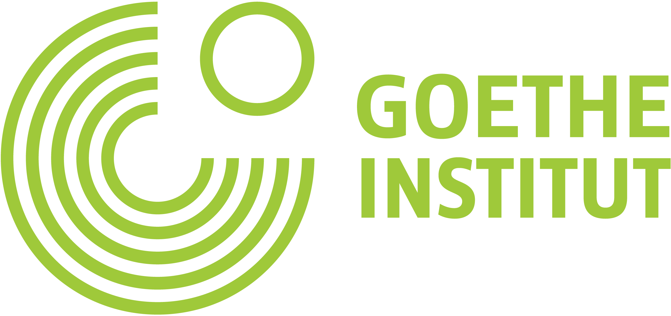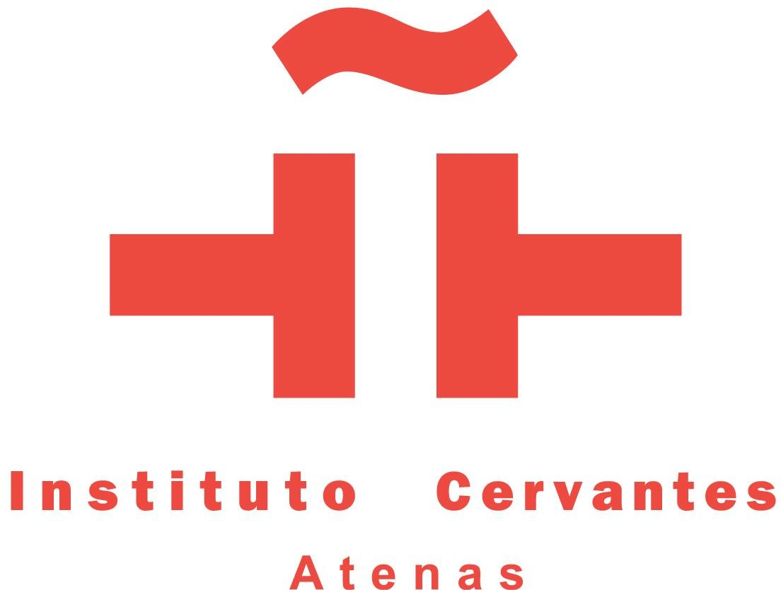
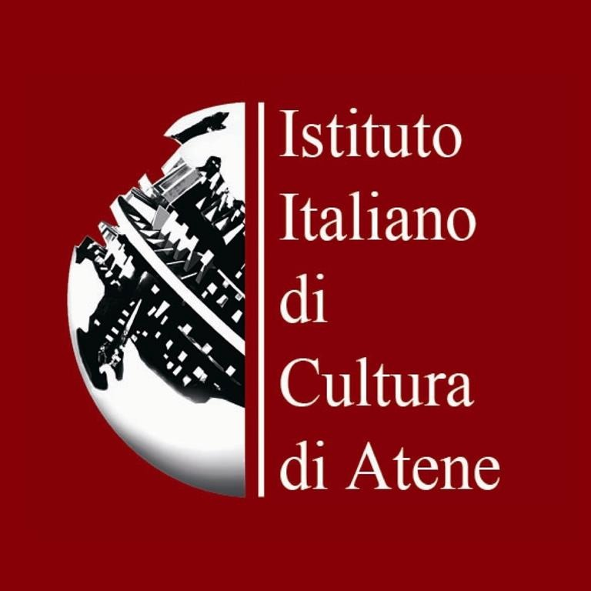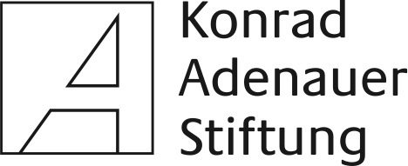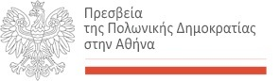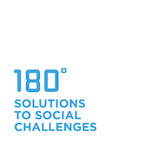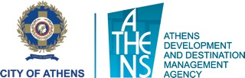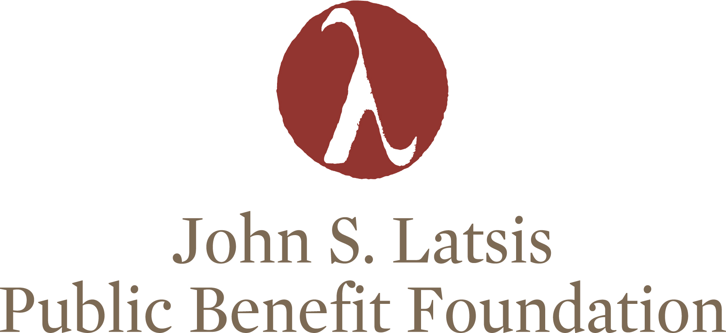

Monday, 2/12/13
Venue: Instituto Cervantes de Atenas, 23 Mitropoleos Street, Athens

9.00h Arrival and registration of the participants
10.00h Welcome and Opening Address
Tony Buckby
Director British Council Greece & Chair EUNIC Athens
10.15h Session1
Delivering support structures – Legal and institutional framework

Konstantinos Geormas
Head of Registry of Social Economy of Ministry of Labour

Deborah Kinghorn
Strategic Support officer at Bristol City Council, UK

Alexis Galinos
CEO of Athens Development Agency, City of Athens

Athanasios Papavlasopoulos
CEO, Social Cooperative of Corfu, New Horizons

Sophie Lamprou and Dimitris Kokkinakis
Social Entrepreneurs, Impact HUB Athens

Moderator: Fay Orfanou, Former Secretary Special for EU Funds, Cofounder of αέλια Working Life Lab

11.45h Session 2
Social Finance – Social Investment

Georg Schoen
Venture Coordinator of Ashoka, Austria

Euaggelos Pteroudis
Operational Director, Pancretan Cooperative Bank, Greece

Katie Hill
Social Investment Advisor, City of London Corporation, UK

Moderator: Yiorgos Alexopoulos, Agricultural University of Athens

13.00h Coffee Break, Light lunch
13.30h Session 3
Evidencing Social Impact

Aphrodite Boukidis
Launch Leader Ashoka Greece

Lena Maria Woerrlein
Social Reporting Standard, University of Hamburg, Germany

Ewa Sadowska
Member of Board, Barka Foundation for Mutual Help, Poland

Andreja Rosandić
Sustainability Manager, Central and Eastern Europe, NESsT, Croatia

Susana Balet
Consultant, Stone Soup, Spain

Moderator: Ivan Juric, John S. Latsis Public Benefit Foundation

15.00h Session 4
Social Entrepreneurship Research & Capacity building within Universities

Oliver Beckmann
Social Entrepreneurship Akademie, Germany

Michele Mosca
Iris Network (Research Network on Social Entrepreneurship), Uni. Naples, Italy

Lina Ioannou
Business Unit of Entrepreneurship and Innovation at Athens University of Economics and Business

Karl Belizaire
Policy Manager Unltd, UK

Gabriel Amitsis
Associate Professor of Social Security Law, Technology Educational Institute of Athens

Moderator: Marios Chatzidamianos, Social Economy Knowledge Broker

16.30h Closing

Tuesday, 3/12/13
Venue: British Council, 17 Kolonaki Square, 106 73 Athens

10.00h Arrival and registration of the participants
10.30h Workshops
max. 30 stakeholders, pre-selection for one Module
Module 1
Institutional and educational tools for social entrepreneurship
Karl Belizaire
Policy Manager Unltd, UK

Module 2
Financial tools

Euaggelos Pteroudis
Operational Director, Pancretan Cooperative Bank, Greece

Manolis Tzouveleka
Phd Cand on Social Finance, Panteion University

Module 5
Working with and for vulnerable groups
Ewa Sadowska
Member of Board, Barka Foundation for Mutual Help, Poland

13.00h Break
13.30h Continuation of the Workshops
Module 3:
Impact Assessment Methodologies
Aphrodite Boukidis
Launch Leader Ashoka Greece

Lena Maria Woerrlein
Social Reporting Standard, University of Hamburg, Germany

Module 4 (Part 1):
Local Development and social entrepreneurship

Deborah Kinghorn
Strategic Support officer at Bristol City Council, UK

16.00h Break
16.15h Continuation of the Workshops

Module 4 (Part 2):

Youth Unemployment & Social Entrepreneurship
in dialogue with Local Development

Vassileia Katsani
Founder “Anaplous”

18.00h Closing

***

